**Sai Manasa Sudha . J**

**SJSU id :010032555**

**CMPE 280**

**Build your Pizza Assignment**

**Screenshots**

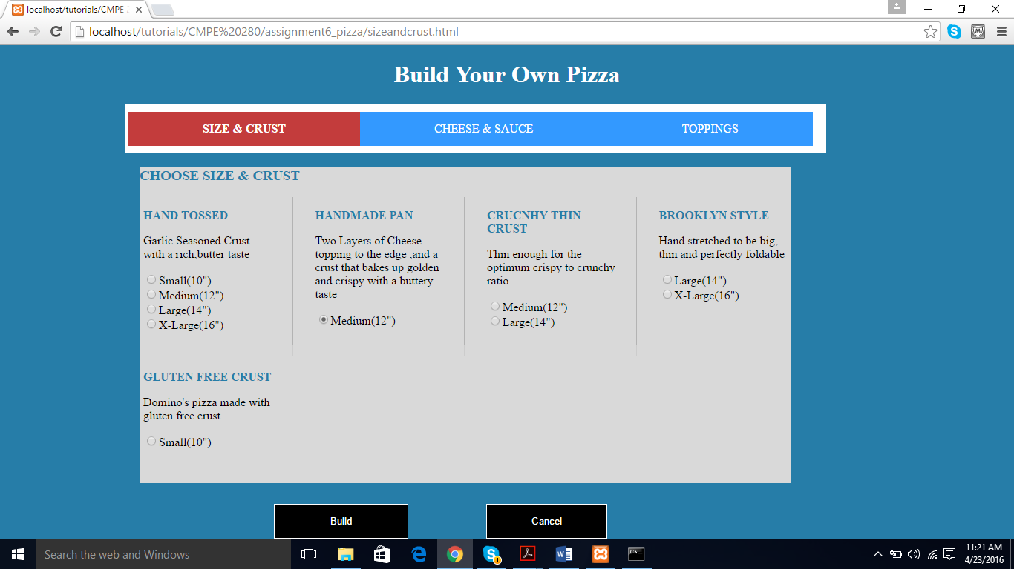

Figure 1 : Size and Crust (home) page of the build your pizza

The above screen shot refers to the size and crust page, where the user is allowed to choose the size of the pizza. On clicking the “build” button, the user navigates to the ‘cheese and sauce’ page.

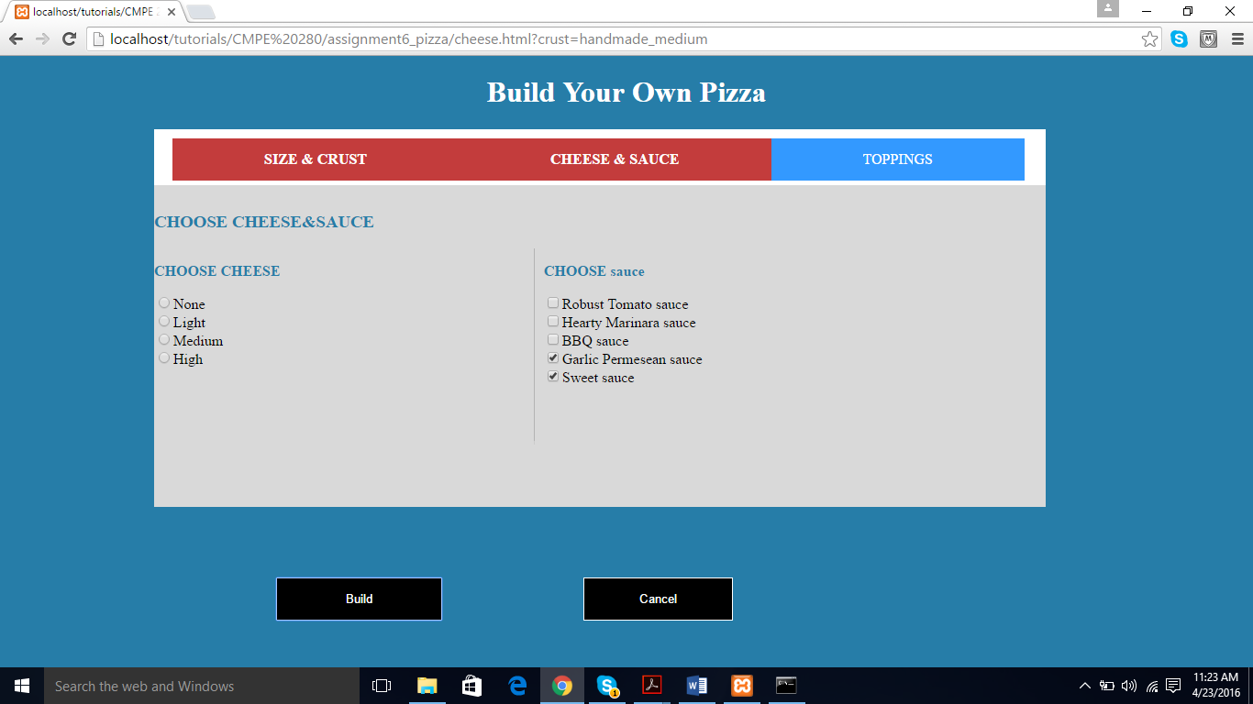

Figure 2 : Cheese and sauce page.

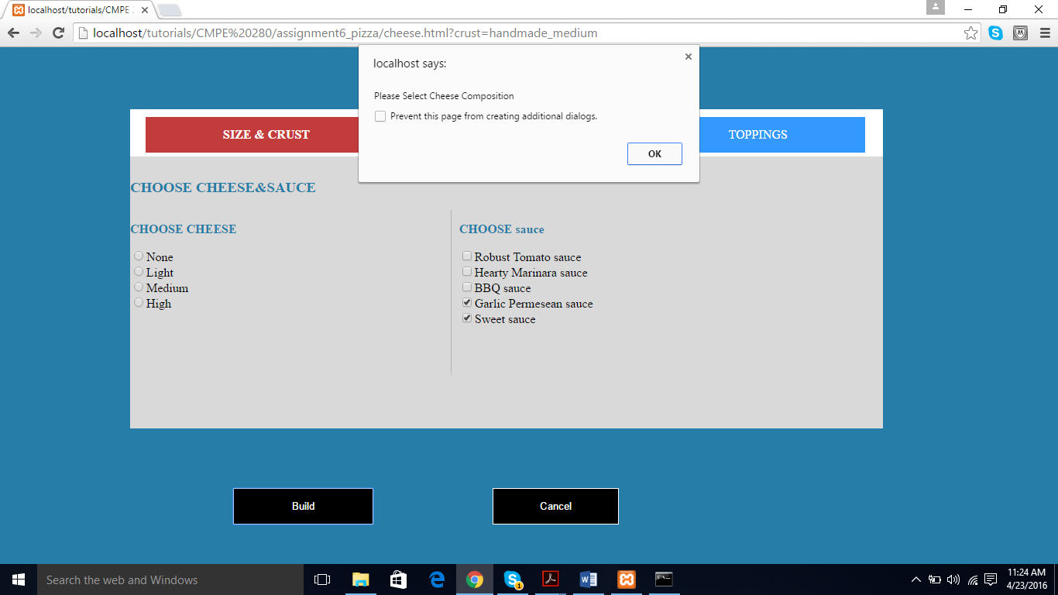

Figure 3 : Error prompted to the user if cheese composition is not selected and instead ‘build’ button is clicked.

In the above screenshot it can also be observed the crust being passed as a query string parameter to the cheese page.

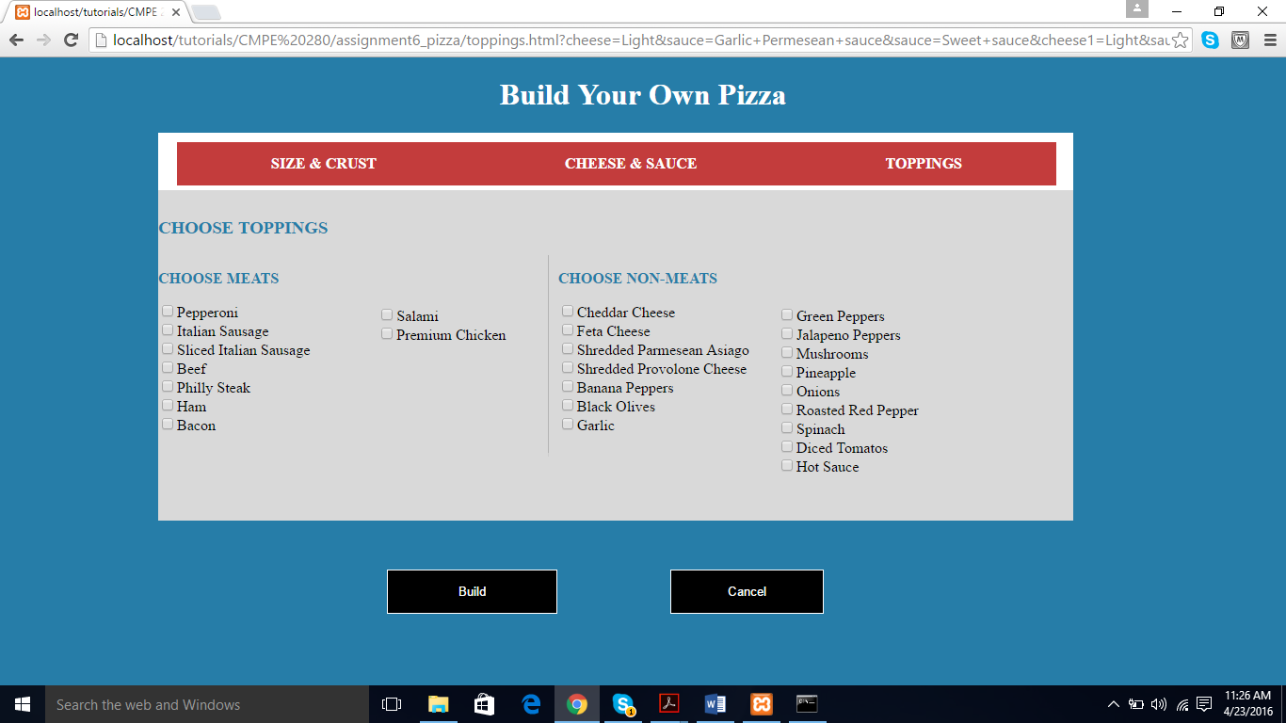

Figure 4: Toppings page

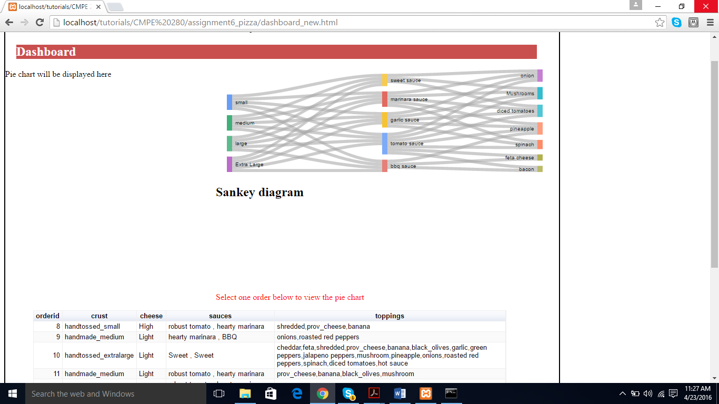

Figure 5 : Dashboard with Sankey diagram

The Sankey diagram represents the flow of the pizza build. Starting from the size selected to the sauce selected and further to the toppings selected. It analyses the user’s orders and plots the trends, for eg: “*people who have ordered small pizza have typically chosen all sauces and the 7 most prominent toppings*”.

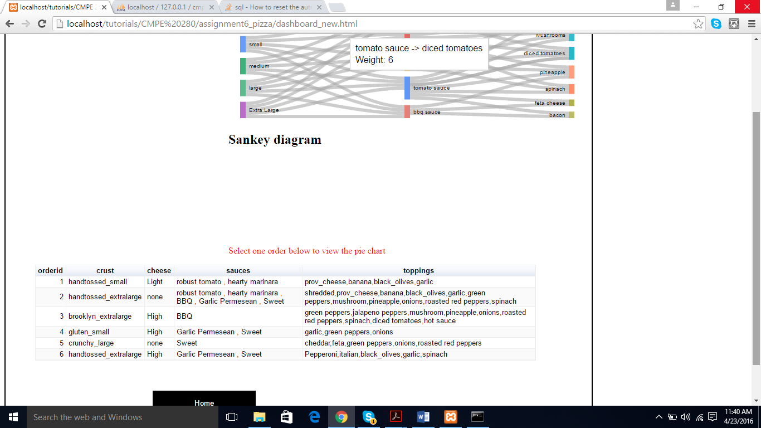

Figure 6 : Google table representing all the orders made by people

This google table gets the statistics from the database and presents in a user friendly table.

On the click of a row , the pie chart is activated as follows:

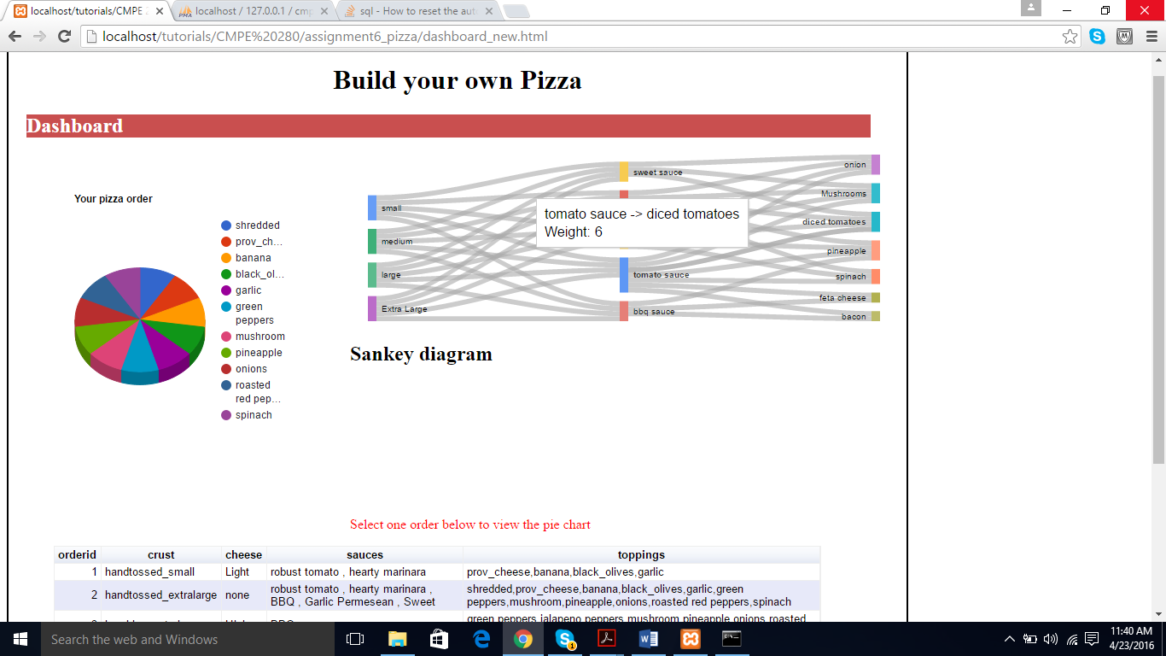

Figure 7 : Pie chart being displayed for second selected row of the google table.

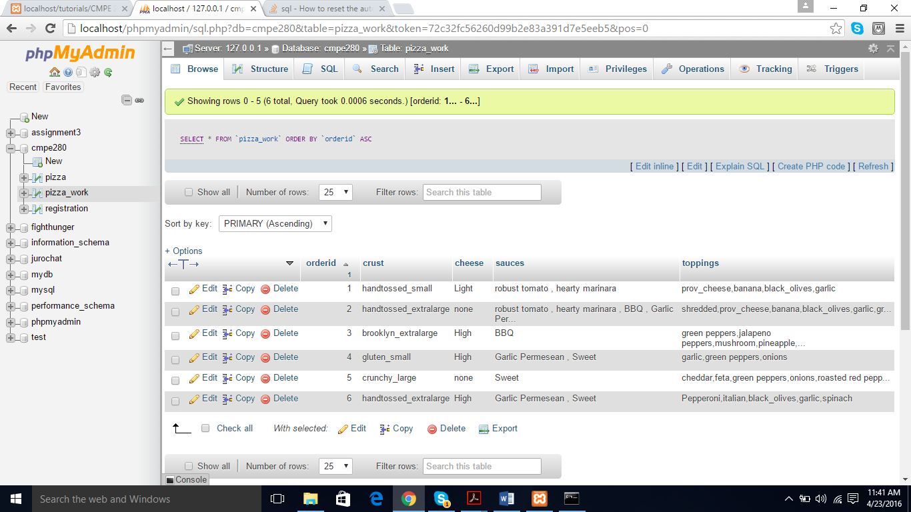

Figure 8 : Database structure